**Documentation:**

**Steps:**

* Approach/Portfolio type is selected (Aggressive or Very Conservative) with mean (Return) and Standard Deviation (Risk) values.
* Range is set to generate random values between minimum and maximum. Minimum ( Return + 3*Risk ) and Maximum ( Return + 3*Risk).
* Investment after 1 year is computed by y1 = (3.5% * x) + (r * x). Where 3.5% is the given inflation rate which is constant for all simulations. “x” is the investment value which is $100,000. “r” is the random number generated using random function.
* 20 random numbers are generated (return values) to compute investment returns for 20 consecutive years. This marks the end of one simulation. Similar approach is followed to execute 10,000 simulations (invovled generation of 20,000 random numbers).
* Java (eclipse luna version IDE) code is written to compute the above tasks. An array is used to store 10,000 simulation values in a sorted manner (ascending order).
* Thus 90th percentile value (10% best case) is 8999 cell in the array and 10th percentile value (10% worst case) is 999 cell in the array.
* Test cases are automated using Junit framework.
* Below are the results obtained after performaing simulation by considering all above conditions.
* Note: Comparing both the portfolio types, aggressive is considered better based on he median values obtained.
* **Given**

|  |  |  |
| --- | --- | --- |
| Portfolio Type | Return (Mean) | Risk (Standard Deviation) |
| A – Aggressive | %9.4324 | 15.675 |
| I – Very Conservative | %6.189 | 6.3438 |

* **Results**

|  |  |  |  |
| --- | --- | --- | --- |
| Portfolio Type | Median 20th Year | 10% Best Case | 10% Worst Case |
| A – Aggressive | 628747.8 | 2534150.9 | 142726.3 |
| I – Very Conservative | 580227.3 | 1029875.1 | 321031.6 |

* Code pushed to git



**Screenshots:**

* Below attached are the supporting screenshots for comparing the values in the INVESTMENT CHECKUP of manual portfolio. The investment value is $100,000.
* Below are the Future projection values based on Monte Carlo simulation principle by setting the default inflation/target rate values of Aggressive and Very Conservative approaches as 0.5% and 2.0% respectively during the 24th year period.

|  |  |  |
| --- | --- | --- |
| Portfolio Type | Return (Mean) | Risk (Standard Deviation) |
| A – Aggressive | %9.2 | %15.5 |
| I – Very Conservative | %6 | %4.6 |

|  |  |  |
| --- | --- | --- |
| Portfolio Type | Median 24th Year | 10% Worst Case |
| A – Aggressive | 213,000 | 91,200 |
| I – Very Conservative | 171,000 | 115,000 |

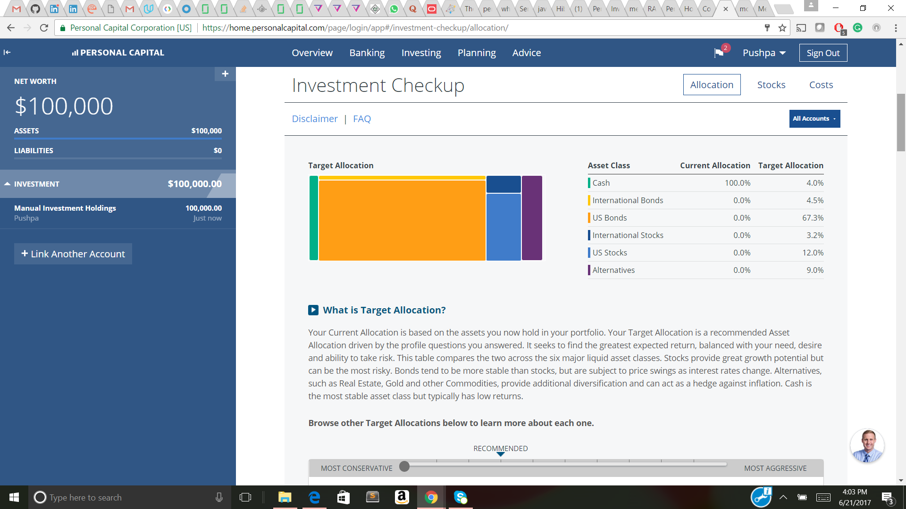

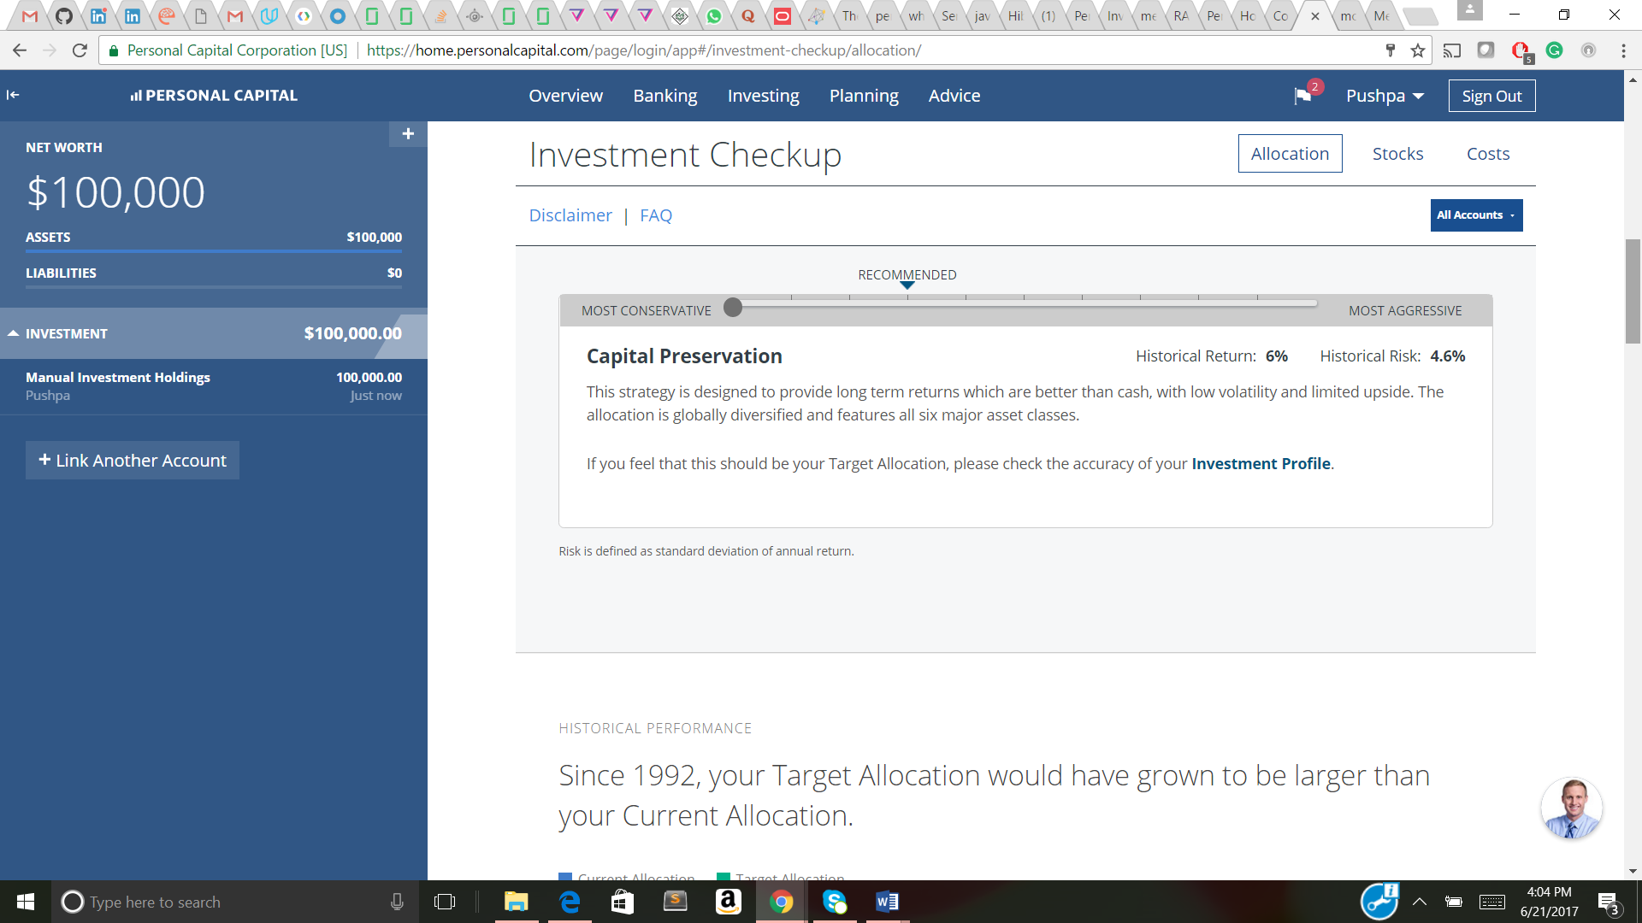

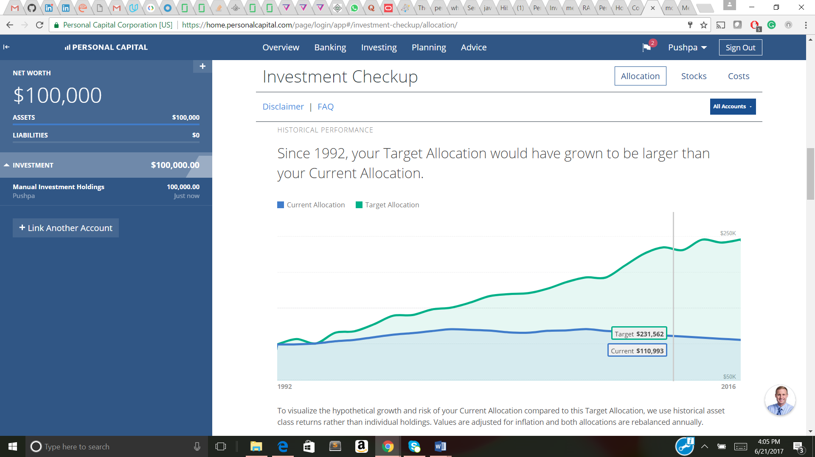





**Note:**

Although both the systems (personal capital manual portfolio and the coding project) rely on the same principles, they cannot be compared directly (in an accurate way), as both of them involve the generation of random numbers for simulations.

**References:**

* <https://support.personalcapital.com/hc/en-us/articles/201170250-What-does-the-Monte-Carlo-section-show->
* <https://home.personalcapital.com/page/login/app#/investment-checkup/allocation>
* https://support.personalcapital.com/hc/en-us/articles/201169980-How-do-I-add-Manual-Investments-Holdings-